DEVOPS ASSIGNMENT

Assignment 1- installation and integration of the build tools:

1. Create freestyle Jenkins job to download code from Git?

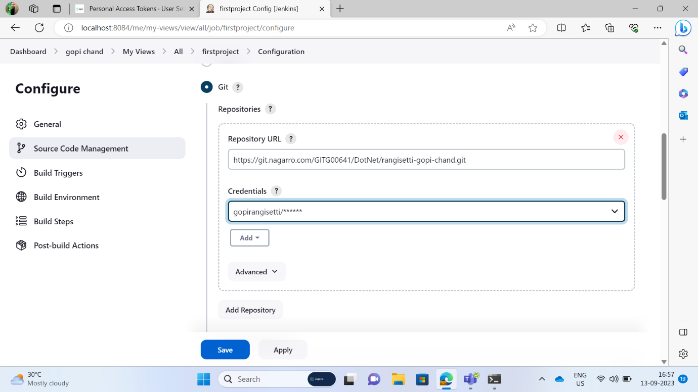

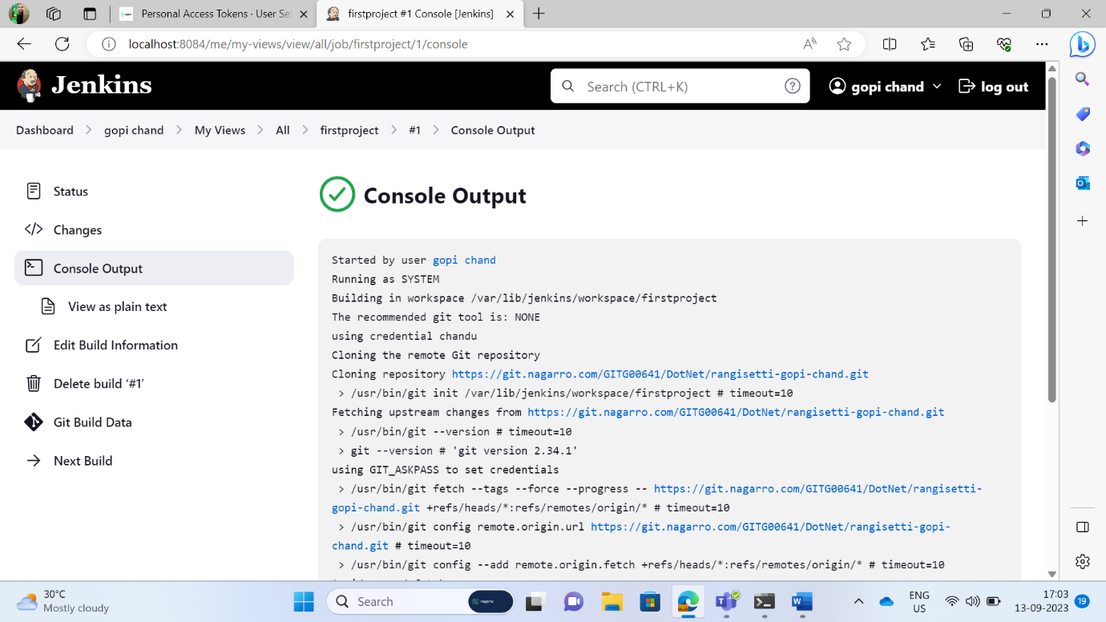

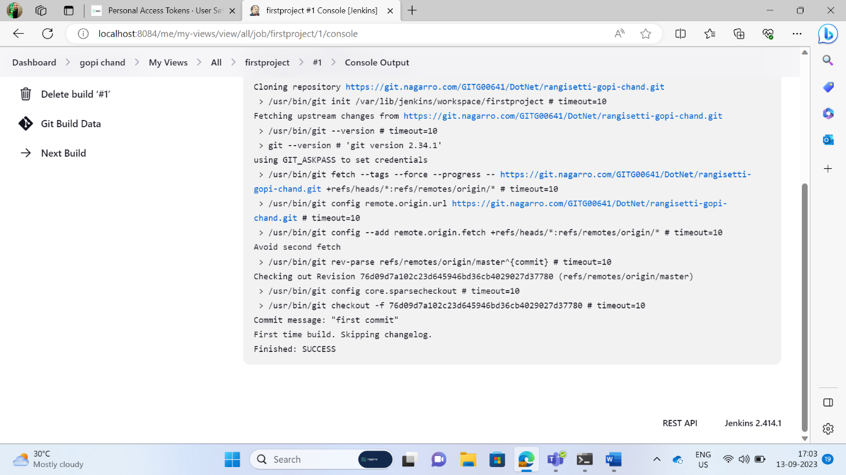

1. Create pipeline to build and test basic .net project code.?

Assignment 2 – CI/CD using Jenkins with Docker.

1. Create freestyle Jenkins pipeline to build and deploy a .NET Core API/Web App using Docker.?



